Statement of Work
Version 0.1 | 10/30/2025

Grainger plc
Lead Optimisation - Consulting

Contents
1. Statement of Work 3
1.1 Overview 3
1.2 Solution Overview 3
1.3 Objectives 3
1.3.1 Consulting Phase 3
1.3.2 Delivery Phase 4
1.4 Responsibilities 4
1.5 Availability 5
1.6 References 5
2. Delivery Approach 6
2.1 UAT 7
2.2 Support 7
3. Software Development Process 8
3.1 Secure Software Development Policy 8
3.2 Artificial Intelligence (AI) Development Tools 8
4. Assumptions & Exclusions 9
4.1 Assumptions 9
4.2 Exclusions 9
5. Cost and Timelines 10
6. Acceptance 12

- Statement of Work
- Overview
This Statement of Work (“SOW”) is entered into between Open Box Software (Pty) Ltd (“Open Box”), and Grainger plc (“Grainger”).
Grainger have requested that Open Box assist in reviewing and redesigning their existing Lead Management process within Salesforce.
The project aims to improve lead conversion through faster response times, customer self-service capabilities, and automations while leveraging existing licences. This project will focus on the initial part of the lead management process up until the customer’s final viewing.
Improving lead conversion rates would reduce the cost per let, requiring fewer leads to fill vacant units and, in turn, reducing the workload required to manage fewer leads. A guided, system-led process would make it easier to skill-up staff to temporarily assist the Lettings Team at peak periods, and would enable Resident Services Teams to serve customers and schedule viewings.
- Solution Overview
The proposed solution would address the following objectives:
- Speed of Response – Improve the speed with which Grainger responds to new customer leads within an agreed timeframe that can be monitored and measured.
- Self-Serve Capability – Enable customers to proceed further in the enquiry journey before the Lettings Team needs to intervene. Allow customers to access more information about relevant properties and select viewing times; potentially booking viewings for vacant units online.
- Lead Conversion Automation - Further automate the enquiry process in Salesforce to produce a qualified lead with minimal intervention from the Grainger Lettings team, enabling the customer to self-serve as much as possible. Automate the lead nurture journey, such as ‘keep in touch’ communications where a proceedable leads does not convert to a let.
- Property Matching – Assist Grainger users in identifying similar units in the same area that a lead may also be interested in. Potentially automating suggestions of similar units where a proceedable lead does not convert.
- Communication Channels – Integrate relevant communication channels in Salesforce (which may utilize Salesforce, Zoom Contact Centre and other providers). Provide a seamless omni-channel experience for the customer where a Grainger user can pick up a communication from any channel and continue the conversation.
- Data – Improve data quality controls. Ensure relevant customer data is collected to support reporting and analytics (such as improved visibility into the source and channel of leads).
- Objectives
This project will be addressed in two phases:
- An initial consulting phase to design the future-state Lead Management process.
  - On completion of this phase, Open Box will provide an updated cost and timeline estimate and Grainger will decide whether to continue with the project.
- A subsequent delivery phase will include sprint zero, solution build, UAT & post go-live support.
    - Consulting Phase
The objectives of this phase are to:
- Conduct a series of workshops with Grainger stakeholders to review the as-is process maps (to be completed by Grainger), assess the key solution requirements, and design a future-state Lead Management process.
- If necessary, develop a proof-of-concept that demonstrates key aspects of the proposed solution.
- Compile a feature backlog in Jira that captures the outcomes to be delivered.
  - The backlog will be used during an iterative delivery phase to identify, develop and deploy the most valuable features for each release.
  - The features will be sized and prioritized relative to each other.
  - Note this initial engagement will not provide detailed user stories; these will be addressed in the subsequent delivery phase that includes sprint zero.
- Open Box will deliver a solution proposal document that includes:
  - A high-level, future-state process diagram.
  - A high-level design for the features to be delivered, including:
    - Proposed data model
    - Recommended project phasing, if more than one release is required.
    - Integration
    - Recommended approach to:
      - Data sharing and visibility
      - Data archival
      - Document/file management
      - Reporting
- Provide a revised forecast of the number of sprints, cost & timeline required to deliver the proposed feature backlog.
  - Note that costs and timelines are forecasts that will be continuously refined throughout the project, based on continuous feedback, backlog refinement and re-prioritization.
    - Delivery Phase
The objectives of this phase are to:
- Work with the core Grainger project team to break down the features identified in the consulting phase into a backlog of user stories with detailed acceptance criteria and technical designs.
- Provide an updated forecast of the number of sprints, cost & timeline required to deliver the project backlog, as and when project scope changes.
- Deliver the solution proposed and approved by Grainger in the consulting phase.
  - See Delivery Approach.
- Provide a user guide.
- Responsibilities
- Open Box will be responsible for:
  - Providing the services and deliverables described in the Objectives.
  - Delivering a progress report to Grainger on a regular basis that will include:
    - Progress and milestones.
    - Any outstanding deliverables.
    - Hours utilized to date.
    - Forecast of remaining hours that are likely to be required by Open Box.
- Grainger will be responsible for:
  - Mapping out the current ‘As Is’ Lead Management process prior to the commencement of this project and identifying the aspects of the process that this project should focus on.
  - Making key personnel and stakeholders available to Open Box.
  - Making a Grainger project sponsor available to facilitate decision making.
  - Delivering any information required in a timely manner.
- Availability
- Open Box resources will be contactable and available for meetings via conference calls/video conferences:
  - Monday to Friday 9am – 6pm South African time (GMT +02:00) which currently corresponds to 8am – 5pm BST, excluding public holidays.
- All work will be completed by Open Box offsite.
- References
- Lead Optimisation – SOW Discussion Zoom meeting held on 22/10/2025.
- Delivery Approach
The delivery approach will be based on the agile SCRUM framework. Iterative delivery is achieved through a series of 3-week sprints. An agile delivery approach allows for the early delivery of outcomes and provides flexibility to adjust for any unforeseen opportunities or issues uncovered during the project.
A backlog of features and user stories will be maintained to track outcomes to be delivered and indicate priority of these outcomes relative to each other. The backlog will be a living artifact that will evolve as Open Box and Grainger collaborate and will serve as the single source of truth with regards to scope.
During Sprint Zero, Open Box will work with the core Grainger project team in backlog refinement sessions to break down the features identified in the discovery phase into detailed user stories. Sprint Zero will not deliver all user stories to be addressed in the project, but will provide a sufficient backlog of user stories that enables the delivery team to commence development in Sprint 1.
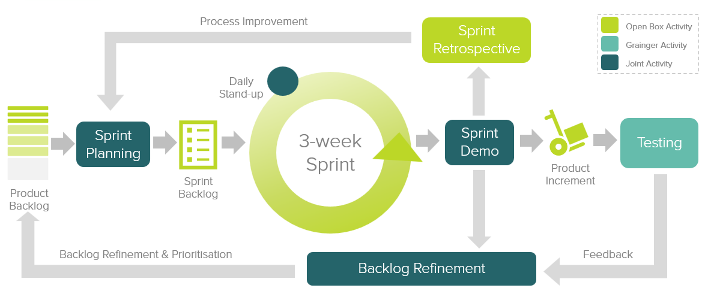
Figure 1: Agile Delivery Approach
Grainger representatives will participate in the following during each sprint cycle:
- Backlog Refinement – Open Box and Grainger representatives will meet to prioritise user stories on the backlog as well as review and agree on acceptance criteria for user stories at the top of the backlog.
- Sprint Planning – Outcomes on the backlog will be selected for the next sprint.
- Demo – Open Box will meet with Grainger representatives to demonstrate the outcomes delivered in the past 3-week period.
- Testing – Open Box will be responsible for unit testing and QA testing of functionality. Grainger representatives will conduct user acceptance testing of new functionality delivered in each sprint and provide feedback.
- Stand Up – Daily, 15-minute stand up calls will be held for the Open Box team to internally report on progress. Weekly, 30-minute stand up calls will be held with the Grainger team to identify upcoming deliverables, discuss potential blockers, provide feedback and give input on any questions that arise.
Feedback from demos and testing will be classified as either bugs or enhancements (depending on the user story and acceptance criteria). Bugs will be fixed in a subsequent sprint, whereas enhancements will be incorporated into the backlog and prioritized accordingly.
If it is expected that the critical functionality can no longer be delivered within the estimated cost and timeline, this will be communicated to Grainger who may choose to resolve this by adjusting the project scope and/or cost & timelines accordingly.
- UAT
Designated Grainger business users will be given access to a UAT sandbox to test the functionality end-to-end and ensure that the overall solution is functioning as expected.
Issues raised will be classified as bugs or enhancements (as above). Bugs will be fixed during the UAT period. Any other enhancements or new requirements will be added to the backlog for future development.
- Support
Open Box will provide post go-live support for 10 working days immediately following the production deployment.
After this period, any critical production issue will be addressed by the existing support agreement with Open Box. Any non-critical changes may be addressed though the existing BAU contract.

- Software Development Process
- Secure Software Development Policy
- Open Box personnel, including any outsourced personnel, will follow the Open Box Secure Software Development Policy when performing software development and implementation.
- This policy includes, but is not limited to, the following:
  - Separated responsibilities for development, testing with a designated person(s) for production deployments.
  - Ensuring confidential and restricted (e.g. personal, financial, health) production data is not used in development or testing environments unless required.
  - Considering privacy and security at each stage of the Software Development process.
  - Completing code reviews for major development changes.
- A copy of the Open Box Secure Software Development Policy is available on request.
- Artificial Intelligence (AI) Development Tools
- Open Box may, at its discretion, use Large Language Model (LLM)-based generative AI coding tools ("AI Tools") in the design, development, testing and delivery of software solutions and related services under this Agreement. Open Box will remain responsible for all outputs produced.
- AI tools such as GitHub Copilot and Microsoft Copilot may be used to assist with delivery of the project.
- Assumptions & Exclusions
- Assumptions
The following assumptions have been made; incorrect assumptions may affect cost and timelines.
- It is not expected that the project will require any data migration.
- Exclusions
The following is not included in the cost or scope of this project:
- This project will not address all lead-related enhancements. This project aims to improve the initial part of the Lead Management process up until the customer’s final viewing. As such, no changes will be made to the current functionality of the lettings portal or referencing process.
- It is expected that enhancements to capture detailed marketing channel data (linking Google or Meta ad clicks to leads and sending conversion data back to Google/Meta) would be addressed as a separate project or as part of the BAU project.
- Evaluating existing and potential customer lifetime value is a separate project.
- Any enhancements to the Grainger website (for example suggesting alternate properties or units that the customer may also be interested in).
- Change management or end-user training; this will be the responsibility of Grainger.
- Solution documentation, other than user stories.
- Third-party costs, license fees, subscriptions or services.
- Hardware and infrastructure.
- Cost and Timelines
Open Box will provide the following services:
- Consultancy Phase & Sprint Zero:
  - An Open Box Salesforce Technical Architect, Senior Business Analyst, and Residential Lettings & Operations SME will be available on a time & materials (T&M) basis.
  - Time spent on these phases will not exceed upper bound estimates without prior approval from Grainger.
- Build: An agile sprint team delivering in 3-week sprints. The team will be staffed to include the following skill sets as required:
  - Salesforce Technical Architect
  - Business Analyst
  - Residential Lettings & Operations SME
  - Developer
  - Quality Assurer
  - Project Manager
- UAT support to assist in the UAT process and fix any new bugs identified.
- Production deployment and post-go live Support immediately following the production deployment.

The total cost of this project is estimated to be £134 620 – £175 770.
The total duration of this project is estimated to be 21 - 25 weeks, including 3 weeks UAT and an additional 2 weeks for post go-live support.
Table 1: Estimated Project Cost
Project Phase | Estimated Duration | Estimated Lower Bound | Estimated Upper Bound
Consulting Phase
Consultancy | 4 weeks | £ 15 120 | £ 18 900
Delivery Phase
Sprint Zero | 3 - 4 weeks | £ 8 190 | £ 10 080
Build (3 – 4 sprints) | 9 - 12 weeks | £ 105 300 | £ 140 400
UAT | 3 weeks | £ 2 925 | £ 2 925
Production Deployment &  Post Go-Live Support | 2 weeks | £ 1 950 | £ 1 950
User Guide | Done in parallel with sprints | £ 1 135 | £ 1 515
Estimated Total | 21 – 25 weeks | £ 134 620 | £ 175 770

These costs and timelines are forecasts that will be refined at the end of the consulting phase and after each sprint based on continuous feedback, backlog refinement and re-prioritization.
Assuming a project start date of Monday 17th November 2025 (and a 2-week December break over the festive season), the estimated project timeline would be as below. It is understood that Grainger would ideally like to have the new process deployed to production in May 2026 in preparation for the high volume of leads that are typically handled in June, July and August.
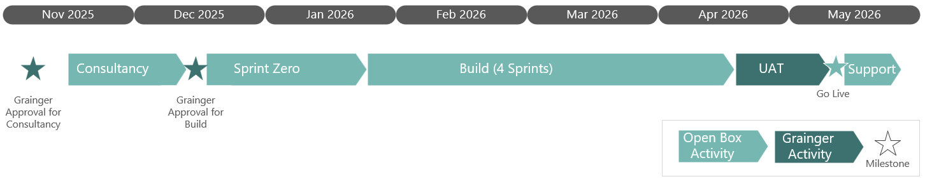
Figure 2: Estimated Project Timeline

- All amounts are in GBP (£) and excludes any VAT or sales taxes, if applicable.
- Costs exclude travel or onsite analysis; the consultancy will be provided remotely.
- Cost will be reported to Grainger on a weekly basis during the project.
- Costs will be billed monthly, in arrears and must be paid within 30 (thirty) calendar days of the date of the invoice.
- This quotation is valid for 30 days.

- Acceptance
The parties hereto, each acting under due and proper authority, have executed this Agreement as of the day, month and year first written below.

For and on behalf of Open Box Software For and on behalf ofGrainger Grainger plc

Signature: _____________________ Signature: _____________________
Name: Sam Duncan Name: _____________________
Position: Salesforce Director Position: _____________________
Date: _____________________ Date: _____________________

